Life-Generating Words

By Loretta Eidson

C:\Users\Jean\AppData\Local\Microsoft\Windows\Temporary Internet Files\Content.IE5\E59EYNZH\MC900286456[1].wmf While reading *Battlefield of the Mind* by Joyce Meyer, it occurred to me the irony of how well that title describes the multitude of thoughts in a writer’s mind. We enter a mental battlefield every time we sit down to write. While our thoughts press against a pliable wall of ideas, we must filter through them before a structured story can emerge in an intriguing manner. We delve into dictionaries and thesauruses in search of the perfect descriptive words that will capture our audience and make a difference.

We study, evaluate, rationalize, and think through all the critiques, recommendations, and guidelines in hopes of catching the attention of a publisher. Sometimes we even doubt our own ability to write a worthy piece—another internal battle.

Joyce Meyer stated, “Our thoughts become our words. Therefore, it is vitally important that we choose life-generating thoughts. When we do, right words will follow.” She is speaking about the power of our words in everyday life, and our spiritual lives. This could certainly be a motto when answering God’s call to write—that we choose life-generating thoughts so the right words will follow.

We pray our words will not disappoint the reader. Our very life-line is—words, so we strive to use them wisely. Now that we understand the power of our words, we must remember the power they have in our everyday life. Pay attention to the words used to communicate with fellow writers and professionals. Words speak volumes to every reader. Our words, whether verbal or on paper, portray personalities and attitudes, beliefs and convictions, approval and disapproval, acceptance and judgment, likes and dislikes.

Psalms 18:21 (NKJV) “Death and life are in the power of the tongue, and those who love it will eat its fruit.”

What we say can create varied emotions in our own lives and the lives of those around us. Words give us our voice. That’s why it is imperative to remember:

Words can hurt. Words can heal.

Words can cause tears. Words can cause laughter.

Words can destroy. Words can restore.

Words can discourage. Words can encourage

Luke 6:45 (NKJV) states, “…For out of the abundance of the heart his mouth speaks.”

However creatively we write or speak, we desire our status as Christian writers to be held in high esteem, simply because we choose life-generating words.

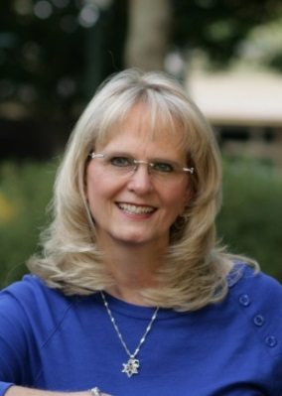

*Loretta Eidson writes romantic suspense and is presently working on a trilogy. Her novel won first place in her genre in the 2014 Novel Rocket Contest, placed in the top 10 of 2013 ACFW Genesis contest, and was a finalist in the 2014 ACFW Genesis Contest. She has non-fiction stories published in various anthologies. Loretta is a Craftsman Alumni of the Christian Writers Guild. She and her husband live in Byhalia, Mississippi*

Facebook: [www.facebook.com/loretta.eidson.7](http://www.facebook.com/loretta.eidson.7)

Twitter: @lorettajeidson